Bicester Town Council



Bicester Traffic Advisory Group Meeting

Ref: BTAG02/2425

Thursday 19th September 2024 at 14:00hrs
Council Chamber, Garth House, Launton Road, OX26 6PS

Group Members:
Cllr Michael Waine (OCC) – Chair
Cllr Dan Hallett; Cllr Donna Ford; Cllr John Willett; Cllr Les Sibley (OCC); Cllr Michael Hewitt (CDC)

Other Circulation:
Cllr Lee Turner (OCC); Cllr Jacqui Cox (OCC);
Chris Hulme (TVP); Miranda Markham (DL- Bicester Vision); Peter Cox (Chamber of Commerce); CDC Group


Council Offices, The Garth,
Launton Road,
Bicester,
Oxon. OX2 6PS
Telephone: 01869 252915
Email: enquiries@bicester.gov.uk
www.bicester.gov.uk

Thursday 12th September 2024

To all members of the Bicester Traffic Advisory Group,

You are hereby summoned to attend the meeting of the Bicester Traffic Advisory Group at
The Chamber Room, The Garth, Launton Road, OX26 6PS on Thursday 19th September 2024 to commence at 14:00hrs for the transaction of following business.

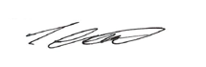

Paul Canning
Acting Town Clerk

Agenda
All Council Meetings are open to the public and press, unless otherwise stated.

Apologies for Absence
To consider apologies and reasons for absence. Committee members who are unable to attend the meeting should notify Bicester Town Council (enquiries@bicester.gov.uk) prior to the meeting, stating the reason for absence.

Minutes of the Bicester Traffic Advisory Group Meeting (Pages 4 – 7)
To APPROVE the MINUTES and RESOLUTIONS of the following Bicester Traffic Advisory Group Meeting held on:
- BTAG01/2425 – Thursday 13th June 2024

Update on Outstanding Items
To discuss any outstanding items not covered on the Agenda.

Presentation from Oxfordshire County Council by Owen Bentley,

Project Manager – Active Travel
A Presentation is to be received on London Road Active Travel Scheme.

Update on 20mph Limits by Anthony Kirkwood – Vision Zero Team Leader (Pages 8 – 13)
Oxfordshire County Council to provide an update regarding the 20mph limits.

Temporary Traffic Regulation Order, for information, discussion? (Pages 15 - 16)
Oxfordshire County Council to provide an update regarding the Temporary Road Closure at Causeway, Bicester

Weight Restriction Order on London Road – Launton Road (up to Londis Garage)?

Forward Plan (Page 16)

The Working Party is asked to NOTE and COMMENT on the Forward Plan.

Date of Next Meeting:

Thursday 9th January 2025 – 2pm, The Chamber Room, Garth House

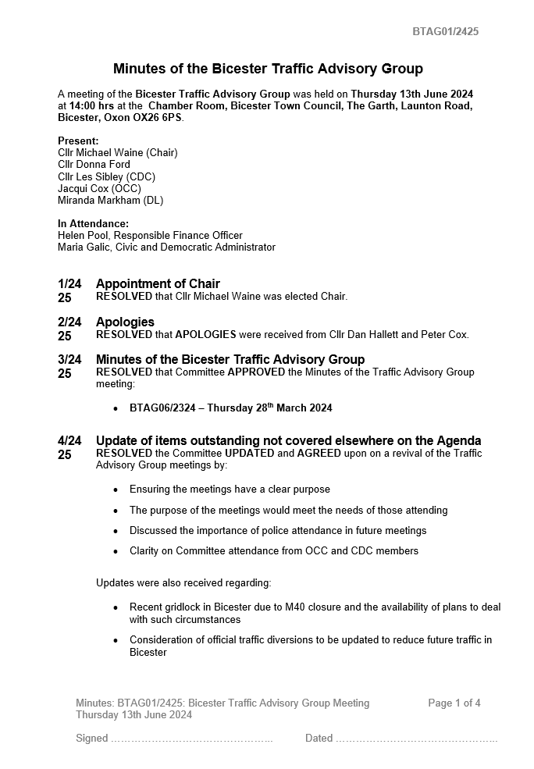
Agenda Item 2
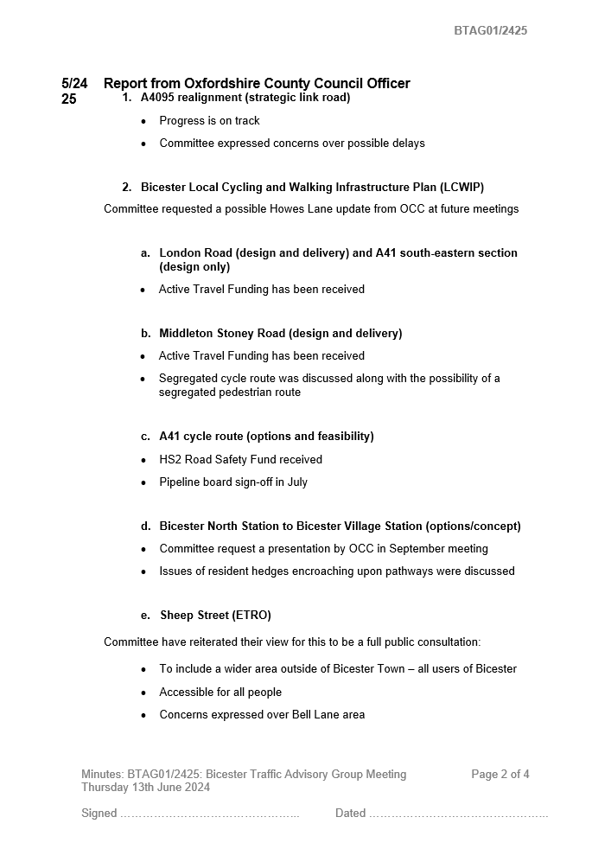

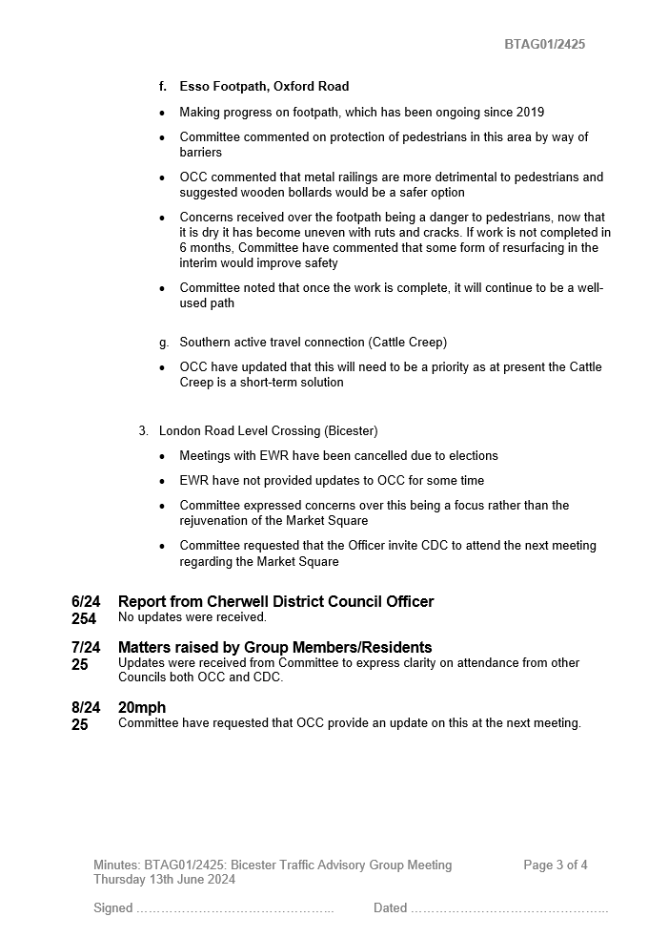
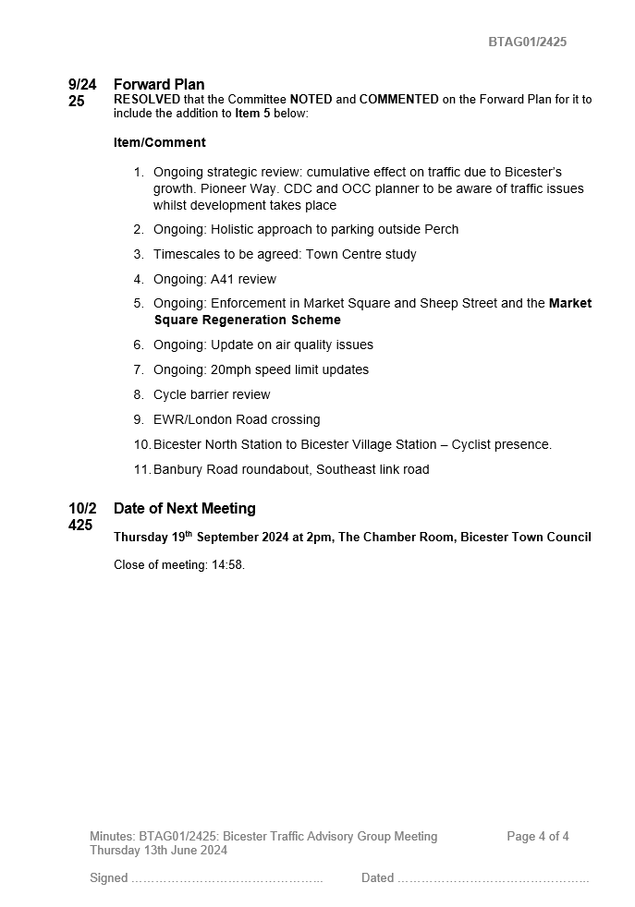
p
Agenda Item 5
The informal consultation generated 1089 responses, while it is a relatively high response level it only represents 3.8% of the (2001) population – perhaps around 5% of households.

Bicester resident | 963
Member of public | 91
Local Cllr (i.e. Town/Parish/District) | 6
Local Bicester-based business | 13
Local Bicester-based group/organisation | 4
Rather not say and 'Other' | 12

Outside of Schools | On main routes such as Banbury Road, Buckingham Road, and Launton Road
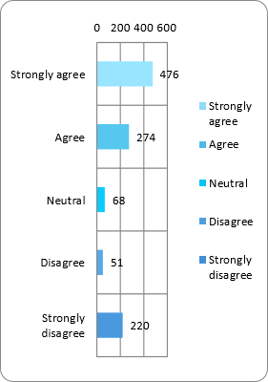 | 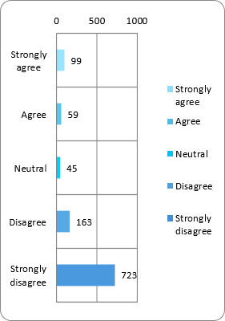

On parts of Main Routes which are more open such as further out from the Central Area | On Roads within Housing Estates
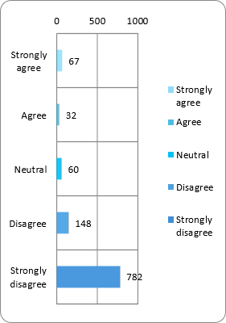 | 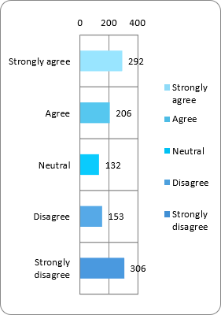

Outside Parades of Shops | On All Roads Within The Town
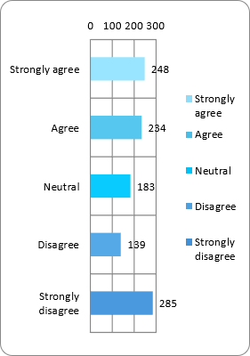 | 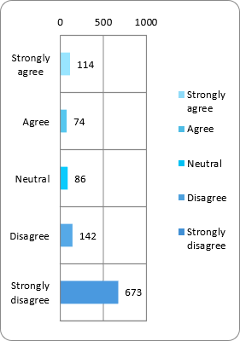

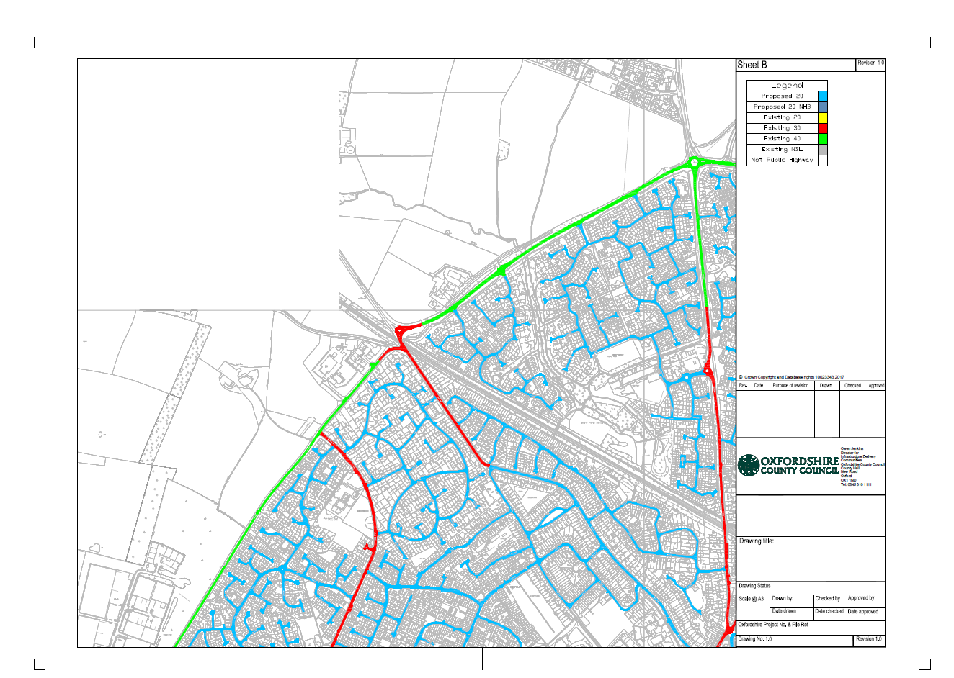

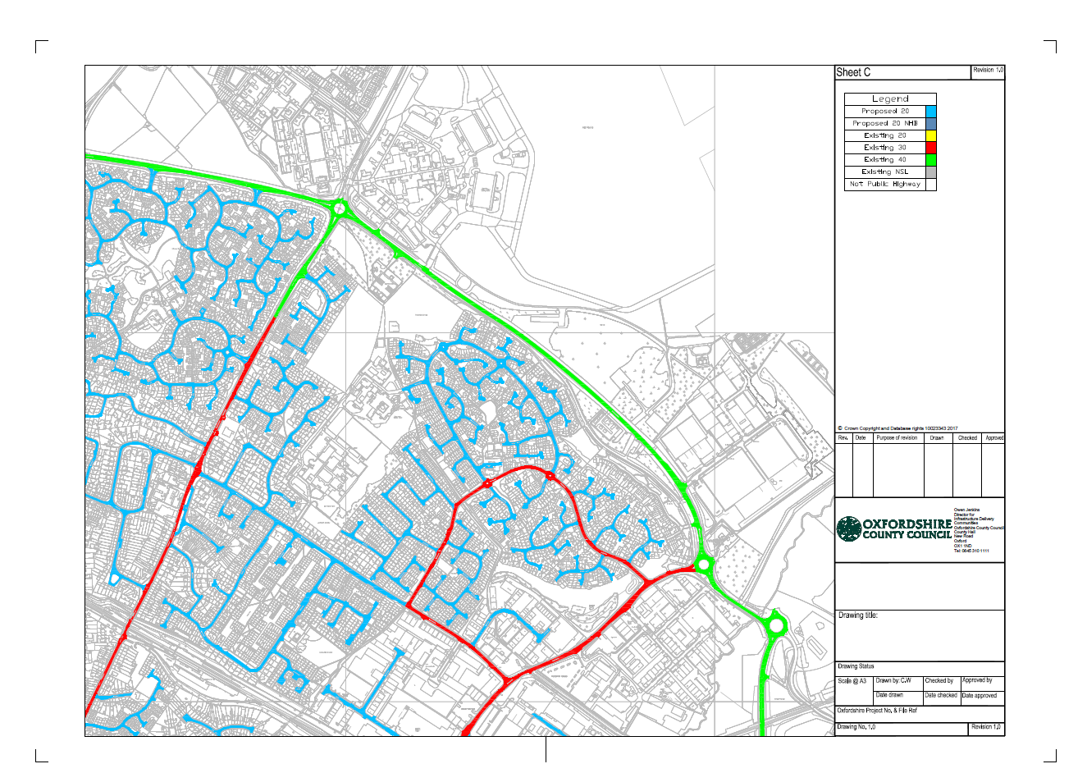

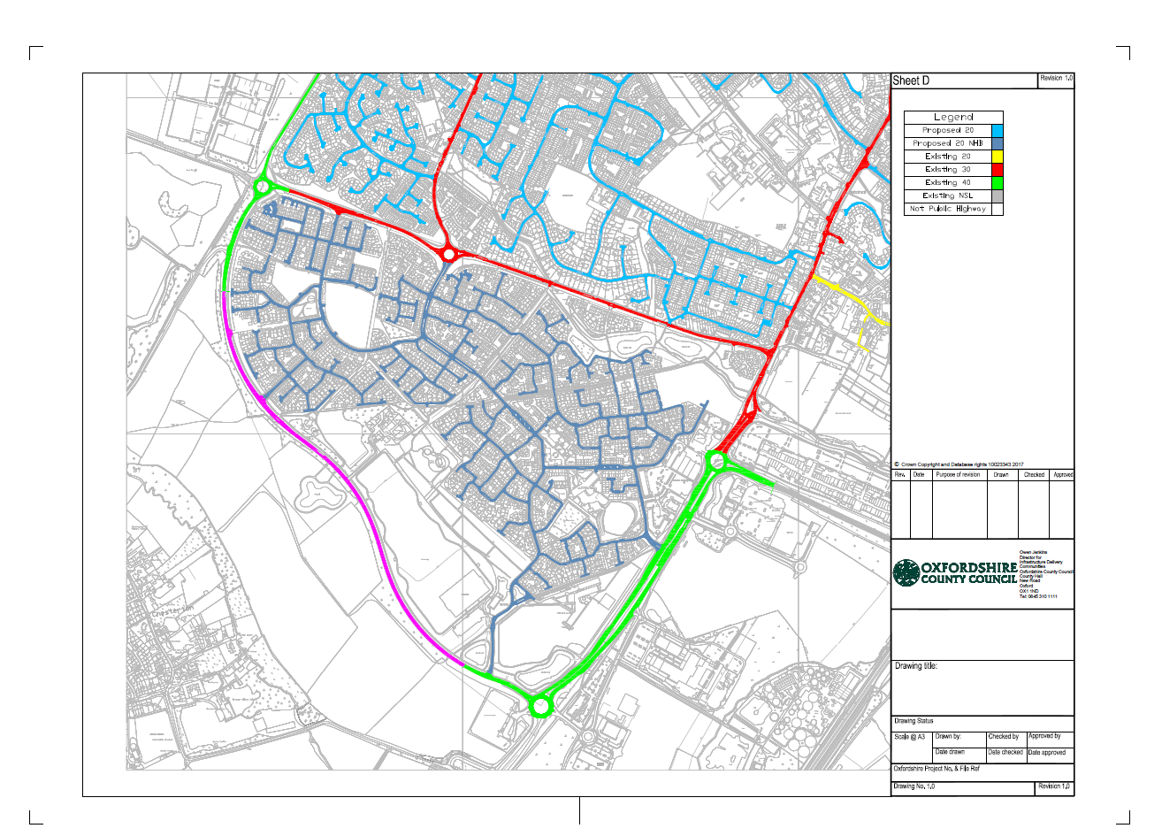

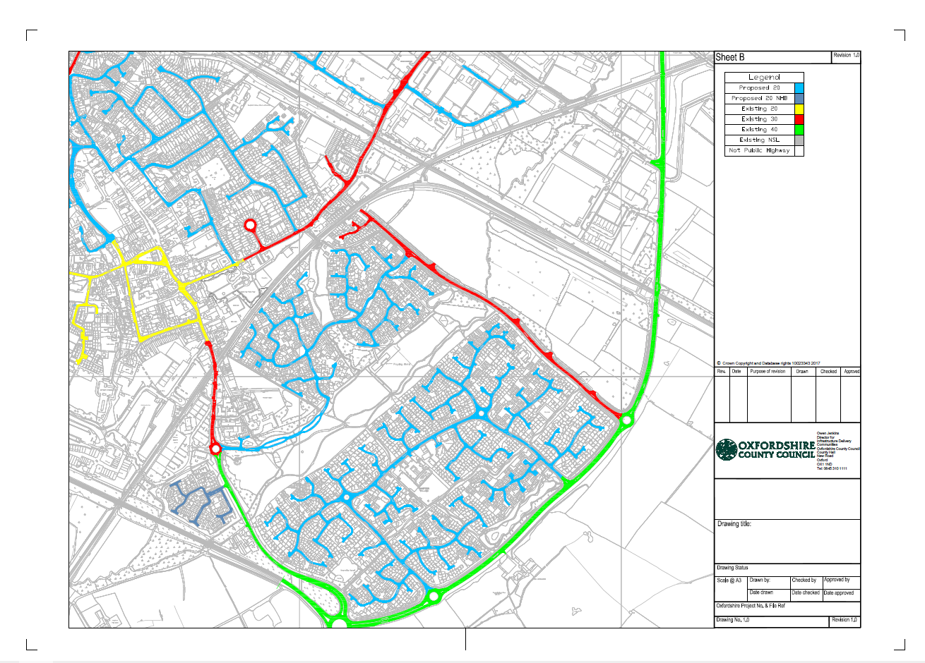

Agenda Item 6

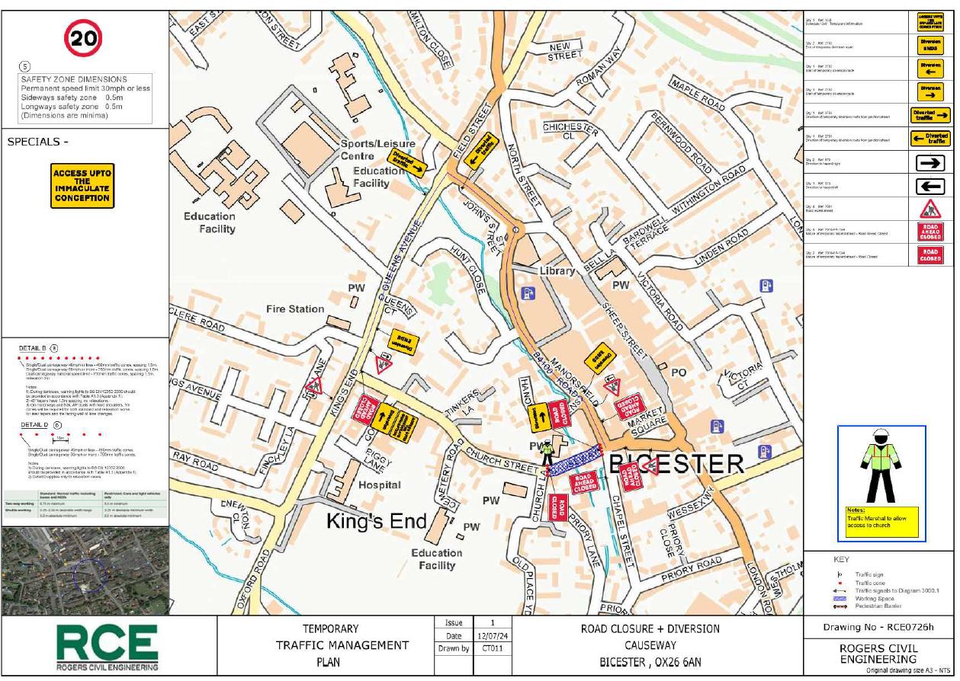

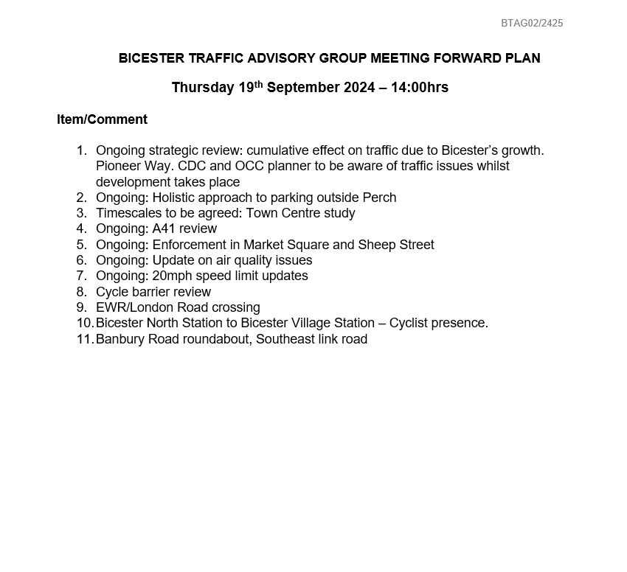
Agenda Item 7

