The Commitment/Challenge

Will you strive for all that makes peace?

We Will.

Will you seek to heal the wounds of war?

We Will.

Will you work towards a just future for all humanity?

We Will.

All to one end.

The Lord’s Prayer – All Together
Our Father,
who art in heaven,
hallowed be thy name;
thy kingdom come;
thy will be done;
on earth as it is in heaven.
Give us this day our daily bread.
And forgive us our trespasses,
as we forgive those who trespass against us.
And lead us not into temptation;
but deliver us from evil.
For thine is the kingdom,
the power, and the glory

for ever and ever. Amen.

Kohima Epitaph – Read by an Officer / Senior Soldier /RBL

“When you go home, tell them of us and say,

“For your tomorrow, we gave our today.

Service Ends

Please be seated in St Edburg’s Church at 11.45am for the commencement of the indoor service at 12 noon

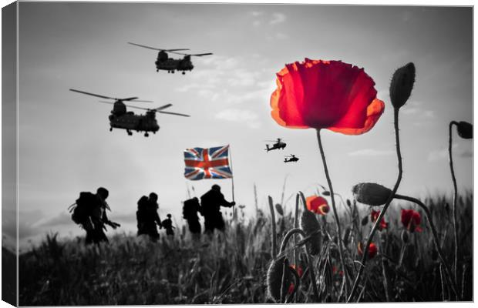

BICESTER
REMEMBRANCE
SERVICE

Words in bold are said by all.

Words in normal are said by the reader.

ACT OF REMEMBRANCE – Read by young soldier

Young Soldier Reads

They shall grow not old as we that are left grow old:
Age shall not weary them,
Nor the years condemn.

At the going down of the sun and in the morning
We will remember them.

And all repeat

We will remember them.

Last Post

Tw0 min silence

Reveille

Parade Stands at Ease (RSM)
Wreath Laying
Service Starts (Padre)

Introduction – Padre
We meet in the presence of God.
Committing ourselves to work for reconciliation between the nations, so that all people may, together, live in freedom, justice, and peace.

Bible Reading (Book of Hebrews) – CO 1 Regt RLC

These were all commended for their faith, yet none of them received what had been promised, since God had planned something better for us so that only together with us would they be made perfect. Therefore, since we are surrounded by such a great cloud of witnesses, let us throw off everything that hinders and the sin that so easily entangles. And let us run with perseverance the race marked out for us, fixing our eyes on Jesus, the pioneer and perfecter of faith.

Remembrance Thought – Padre

A Prayer for the Armed Forces (RSM)
Almighty God, stretch forth your mighty arm to strengthen and protect the armed forces: grant that, meeting danger with courage and all occasions with discipline and loyalty, they may truly serve the cause of justice and peace; to the honour of your holy name, through Jesus Christ our Lord. Amen
The Field Service Book of the British Army

Act of Commitment
Let us pledge ourselves anew
to the service our fellow men and women:
that we may help, protect, and encourage others,
support those working for the relief of the needy
and for the peace and welfare of the nations.

