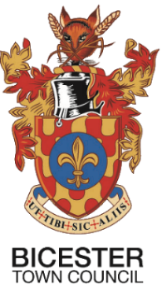
Council Offices, The Garth,
Launton Road,
Bicester,
Oxon. OX2 6PS
Telephone: 01869 252915
Email: enquiries@bicester.gov.uk
www.bicester.gov.uk

Requested Meeting on Monday 14th June 2021

Sir/ Madam

You are summoned to attend a meeting of the Environment Committee will be held on Thursday 17th June 2021 at 19:00hrs at Garth House in the Chambers

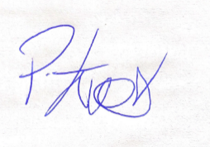 PP.

Samantha Shippen
Chief Officer

Agenda
All Council Meetings are open to the public and press, unless otherwise stated.

Apologies for Absence
To consider apologies and reasons for absence. Committee members who are unable to attend the meeting should notify the Chief Officer (Acting) (phil.evans@bicester.gov.uk) prior to the meeting, stating the reason for absence.

Government Extension to Stage 4 Lock down (19th July)
The Committee is asked to consider the attached report.

BICESTER TOWN COUNCIL

ENVIRONMENT COMMITTEE

Monday 24th May 2021

Government Extension to Stage 4 Lock down (19th July)

Chairman: Councillor Jason Slaymaker
Telephone: Telephone: 07512 902386 jason.slaymaker@bicester.gov.uk

Phil Evans – Service Manager
Telephone: 01869 252915 phil.evans@bicester.gov.uk

Ward Affected: All Wards

- Background
The Government held an update on the 14^{th of} June 2021 at 18:00 to communicate the current situation with the pandemic (variant D)
Before the update the current plan for stage 4 of lockdown easing was set to take place on the 21^{st of} June 2021.
With the new introduction of Variant D recent figures are showing that a rise in cases
As a direct result the government has takin measures reduce further strain on services and loss of life to extend the dates from 21st June until 19th July.
This decision has impacted to events that have been set by the town council
1.Flag raising (25 June)
1.Armed forces and family fun day (26th June)
2.Civic Service and Parade (11th July)
- How does this impact

Armed Forces Day is completely set for progression; however the announcement means that capacity management has to be in place for the event.
The town council do not have sufficient manpower to man all 4 entrances to pingle field nor is there a robust process to assist. We would have to source a process and additional manpower for this to be successfully managed.
We would need additional security in order to maintain safety for the event.
Our current supplier may struggle to meet this, and this will incur cost

Overall, the budget was utilised to its fullest and any additional cost would be in excess to budget
It is also worth consideration that the public perception should this event proceed may not have a desired result.

Flag raising will continue (socially distanced and limited numbers) 30 members only – hand sanitation station will be provided refreshments will be provided with a one in one out policy.

Civic Service and parade the date 11th July has been cancelled by request of the mayor. It is to be rearranged at a later date, once restrictions have eased – The army have requested that 8 weeks’ notice must be given to allow for planning.

- Recommendations

The Committee is recommended to:

APPROVE that we cancel Armed forces and family fun day and look to retain all booked suppliers for event delivery in 2022

APPROVE that we progress flag raising with the above format.

NOTE the Civic Service and parade changes

